DocScript

Documentum Script Administrator

As Built

Table of Contents

1 Glossary of Terms 4

2 Background 5

3 Function 6

3.1 Main Form 6

3.1.1 Run 6

3.1.2 User Name 6

3.1.3 Password 6

3.1.4 Script Type 6

3.1.5 Docbase 6

3.1.6 Script File 6

3.1.7 Results File 7

3.1.8 Working Directory 7

3.2 Quick Access ToolBar 8

3.2.1 Refresh 8

3.2.2 Save 8

3.3 Application Menu 9

3.3.1 About 9

3.3.2 How To… 9

3.3.3 API Doc… 9

3.3.4 Settings 9

3.3.5 Copy 9

3.3.6 Exit 9

3.4 Settings Form 10

3.4.1 Application Values 10

3.4.2 User Values 10

3.5 About Form 11

4 Architecture 12

4.1 Accounts 12

5 Configuration 13

5.1 Deployment 13

5.1.1 Import the certificate 13

5.1.2 Update the application information 13

5.1.3 Build the solution 13

5.2 Client PC 13

# Glossary of Terms

|  |  |
| --- | --- |
| Term | Meaning |
| DocScript | Documentum Script Administrator |
| DQL | Documentum Query Language |
| API | Application Programming Interface |
| Idql | A scripting application for DQL located in the working directory on the content server |
| Iapi | A scripting application for API located in the working directory on the content server |

# Background

This application was created to help with scripting Documentum databases. Multiple scripts can be contained in one file then run as one command.

# Function

The detailed functionality of this application and its components.

## Main Form

The following are all functions of this application.

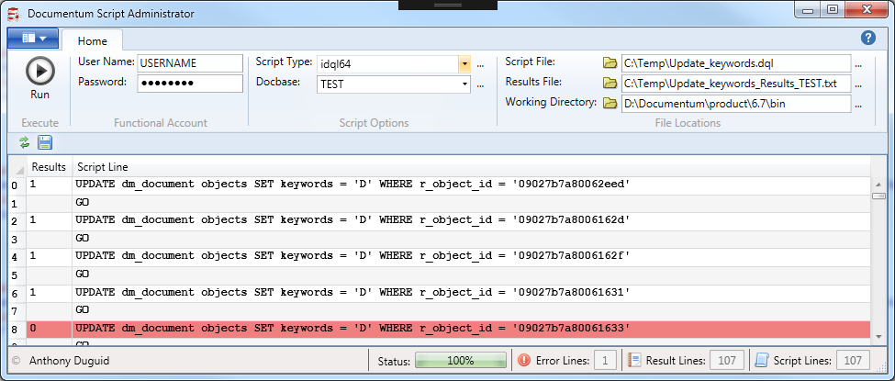

### Run

* This button will first copy the script from the script file directory to the working directory. Then it will execute the script file.

### User Name

* This account must be an administrator in Documentum.

### Password

* The password for the administrator in Documentum

### Script Type

* This is the type of script you can run. i.e. idql32.exe for a 32 bit machine and idql64 for a 64 bit machine.

### Docbase

* A specific docbase must be selected

### Script File

* This file contains one or more than one script files. It has to be copied to the working directory to run.
* The script file can not have any spaces in the file name

### Results File

* This is the file that is created after the script file is run. Unless the path to this file is indicated the default path is the working directory.

### Working Directory

* This is the location of the script type e.g. idql64.exe, iapi64.exe

## Quick Access ToolBar

The following are all functions of the quick access toolbar.

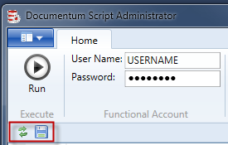

### Refresh

* This refreshes the results column in the datagrid

### Save

* This saves the grid to a csv file

## Application Menu

The following are all functions of the application menu.

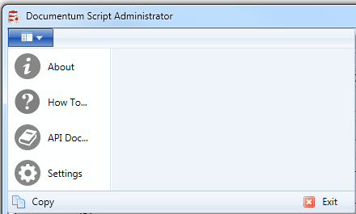

### About

* The about form

### How To…

* Opens the as built documentation.

### API Doc…

* Opens the API documentation.

### Settings

* All the dropdown lists and default values are stored here and can be edited.

### Copy

* Copies the command line script

### Exit

* Closes the application.

## Settings Form

The setting form contains the default values used in the application.

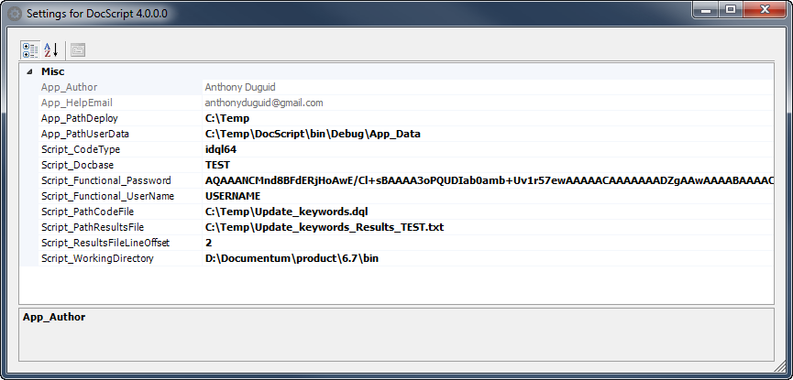

### Application Values

* The grayed out values are application specific and can only be changed in the project before it is compiled.

### User Values

* These values can be changed by endusers.

## About Form

The setting form contains the default values used in the application.

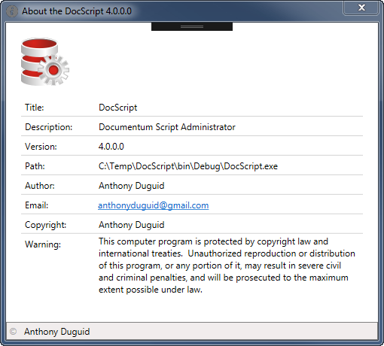

# Architecture

The full implementation comprises the following:

* .Net Framework 4.0
* This application must be run from the Documentum Content server

## Accounts

To run this application you need the administrator account for the docbase.

# Configuration

## Deployment

The configuration for deployment is as follows:

### Import the certificate

1. Go to the “Project Properties… | Signing*” and click “Select from File…”

### Update the application information

1. Select the Assembly Information and change the Assembly version

### Build the solution

1. Save the project, Then run the “Build | Build Solution” from the Visual Studio project
2. Publish the application from “Build | Publish DocScript”
3. Check in your changes to the source control

## Client PC

The client PC configuration is as follows:

* A fat client that is installed to the user’s machine from a click-once install
* The install is per profile on the machine
* A folder is created under “All Programs”